|  |  |  |  |
| --- | --- | --- | --- |
| \\lyng-dc1\StaffShared\Learning Bugs Animals ALL subjects\characters bugs animals\Cyril the Snail - History.jpeg**Lyng Primary School Knowledge Organiser** | | | |
| **History Topic:** | **Would you prefer to live in the Stone Age, Bronze Age or Iron Age?** | Year 3  *Battles, Beliefs and Buildings* | Autumn 1 |

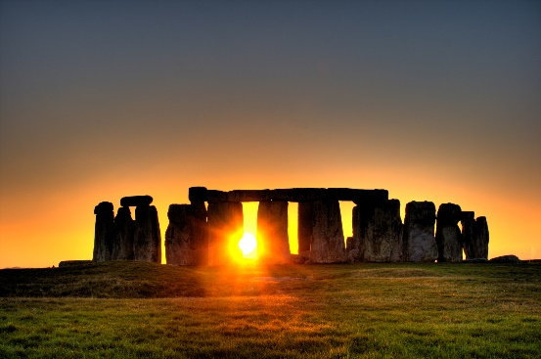

**Background information for parents and teachers**

Prehistory in Britain began with the arrival of groups of hunter-gatherers from further south in Europe around 900,000 years ago and ended with the Roman invasion in AD43. During this huge amount of time, humans developed from hunter-gatherers moving around a sparse country, to people who erected great monuments which still survive today. Prehistory is usually divided into three periods; the Stone Age, the Bronze Age and the Iron Age (and each of these periods can be subdivided). These periods are named after the materials used to make tools and weapons

|  |  |
| --- | --- |
| **What Step On and Goldilocks words will I use?** | |
| **Spelling** | **Definition** |
| agriculture  Image result for agriculture stone age | Farming |
| anachronism | An anachronism is something in a book, play, or film that is wrong because it did not exist at the time the book, play, or film is set. |
| archaeologists | The study of human activity through the recovery and analysis of material culture. The archaeological record consists of artefacts, architecture, bio facts or Eco facts and cultural landscapes. |
| climate | The weather conditions in an area (during the last ice age the temperature in Britain was extremely cold). |
| flint | Flint is a very hard greyish-black stone that was used in former times for making tools. |
| hand Axe | A weapon and tool made from stone and wood. |
| human | We are human, but there have been different humans over time. |
| hunter gatherers | Groups of people who get food by hunting, fishing and foraging rather than by farming. |
| prehistory | The time in the past before people could write. |
| Skara Brae | Skara Brae is a stone-built Neolithic settlement. |
| Stonehenge | A group of standing stones in Salisbury Plain, in Southern England |

|  |  |
| --- | --- |
| **When? (Timeline of key events)** | |
| 814000 BCE | Evidence of flints made into tools in Britain. |
| 40000 BCE | Homo Sapiens arrived in Britain. |
| 33000 BCE | Ice Age drove humans out of Britain. |
| 11,000 BCE | Humans returned to Britain. |
| 4400 BCE | People began to settle across Britain, building farms |
| 3180 BCE | Skara Brae village was built in the Orkney Islands, Scotland |
| 2200 BCE | Bronze Age began in Britain |
| 2000 BCE | Stonehenge was completed and stone walls built. |
| 800 BCE | The Iron Age began |
| 100 BCE | Coins were used for the first time in Britain |
| 55 BCE | Britons in war chariots defeated the Romans |
| 43AD | The Romans invaded Britain again and the Iron Age ended |

**Hook**

**Archaeological Dig (LOTC)**

Discovering prehistoric tools and weapons and predicting their use in the forest area



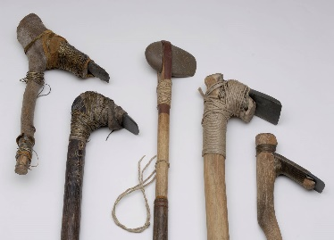

c

**Charles Darwin** – “It is not the strongest of the species that survives, not the most intelligent that survives, It is the one that is the most adaptable to change.”

**Great Quotes**

**Focus Text**

**Our Storytelling Approach to enhance engagement**

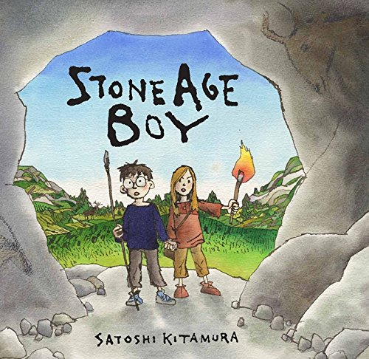

|  |  |  |
| --- | --- | --- |
| **People:**  Stone Age Boy | **Place:**  Prehistoric world with prehistorical creatures | **Problem:**  A boy is trapped in the Stone Age and needs to adapt to their life of huting |

**Key Facts and Famous Figures**

Homo erectus was the ﬁrst human to come to Europe about 2 million years ago. Homo neanderthalensis are also known as Neanderthals. Homo sapiens is us! We arrived 40,000 years ago.

Skara Brae is a prehistoric stone settlement on the coast of the Orkney islands in Northern Scotland. It sits on a bay and is constantly exposed to the wind and waves of the Atlantic Ocean. It was in 1850 that a storm with high tides and wind uncovered Skara Brae. The storm had stripped a lot of grass from the mounds on the beach, revealing the outlines of stone structures.

If you went to Skara Brae today you'd see eight buildings from a path that winds through the site. Each of the dwellings is connected by a series of passages, a bit like alleyways. The passages have stone roofs that allowed the residents to go from house to house even in bad weather.

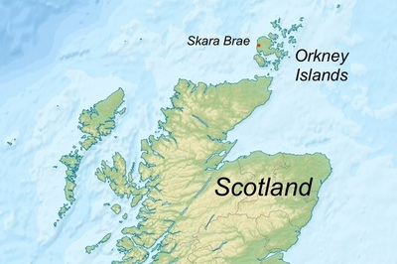

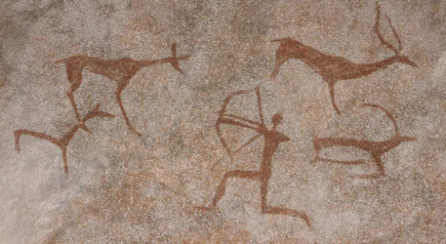

Our Enquiry Questions:

* What are the achievements of Early Humans?
* What does Skara Brae tell us about the stone age?
* Who was the Amesbury Archer?
* How did Bronze change life in the stone age?
* How did trade change the iron age?

**Agreed Outcome**

Stone Age shelter

**Key skills – Taken from Milestone 2 – Sequence of Learning**

|  |  |  |  |
| --- | --- | --- | --- |
| \\lyng-dc1\StaffShared\Learning Bugs Animals ALL subjects\characters bugs animals\Cyril the Snail - History.jpeg**Lyng Primary School Knowledge Quiz** | | | |
| **History Topic:** | **Changes in Britain from the Stone Age to the Iron Age** | Year 3  *Battles, Beliefs and Buildings* | Autumn 1 |

|  |  |  |
| --- | --- | --- |
| 5. A settlement is... | **S** | **E** |
| Where people were hunted |  |  |
| Where people got lost. |  |  |
| Where people migrated to and  live in a community |  |  |

|  |  |  |
| --- | --- | --- |
| 6. Which period was the shortest? | **S** | **E** |
| The Stone Age |  |  |
| The Bronze Age |  |  |
| The Iron Age |  |  |

|  |  |  |
| --- | --- | --- |
| 7. Who was the Amesbury Archer? | **S** | **E** |
| A traveller and metal worker |  |  |
| A teacher |  |  |
| A doctor |  |  |

|  |  |  |
| --- | --- | --- |
| 1. What was the correct order of these events… | **S** | **E** |
| Stone Age, Iron Age, Bronze Age |  |  |
| Bronze Age, Stone Age, Iron Age |  |  |
| Stone Age, Bronze Age, Iron Age |  |  |

|  |  |  |
| --- | --- | --- |
| 1. Hill forts were built for… | **S** | **E** |
| Protection from attack. |  |  |
| Holidays |  |  |
| Travelling |  |  |

|  |  |  |
| --- | --- | --- |
| 1. What does BC stand for? | **S** | **E** |
| 1. Before Christ |  |  |
| 1. Before Christmas |  |  |
| 1. Before churches |  |  |

**Our Stone Age Quick Quiz**

|  |  |  |
| --- | --- | --- |
| 1. What did flint knapping create? | **S** | **E** |
| Tools. |  |  |
| Water. |  |  |
| Animals. |  |  |

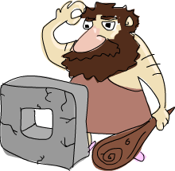

|  |  |  |
| --- | --- | --- |
| 1. Give an example of a weapon that was used in the Stone Age…. | **S** | **E** |
|  |  |  |

|  |  |  |
| --- | --- | --- |
| 1. Somebody who studies the past by exploring old ruins is called... | **S** | **E** |
| Archaeologists |  |  |
| Settler |  |  |
| Invader |  |  |